>> WiFi IP CAMERA DETECTION <<
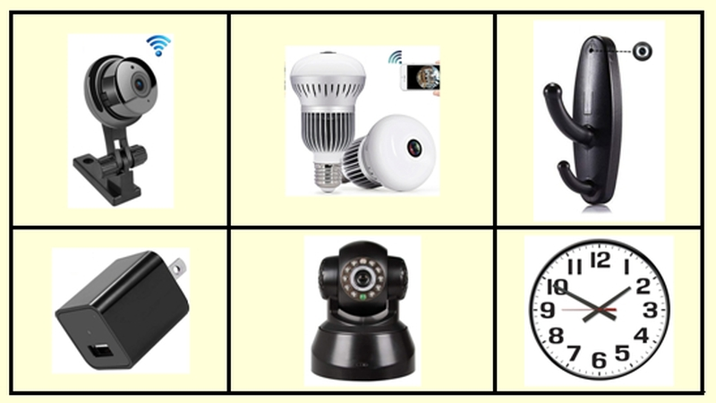
Before detection, first disconnect the WiFi of all devices on the spot to avoid interference.
以免干擾到探測的進行
 VIDEO CAMERA SCAN MODE
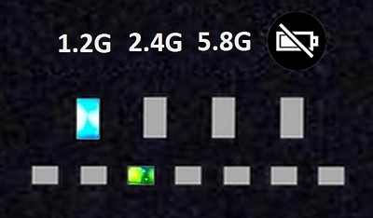
After switch on, this device will enter the default ”Video camera scan” mode and start to scan from 1.2G frequency band, the Blue LED in upper row will light up at 1.2G, the Green LED in lower row will shuttle to-and-fro.
This device will scan during 1.2G – 2.4G – 5.8G cyclically. When shift to 2.4G frequency band, the Blue LED will light up at 2.4G. Likewise, the Blue LED will light up at 5.8G when scan to 5.8G frequency band.

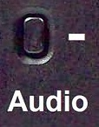
 WiFi IP CAMERA SCAN MODE
1. After switch on, press once the (–) button in left side, this device will enter WiFi IP camera scan mode.
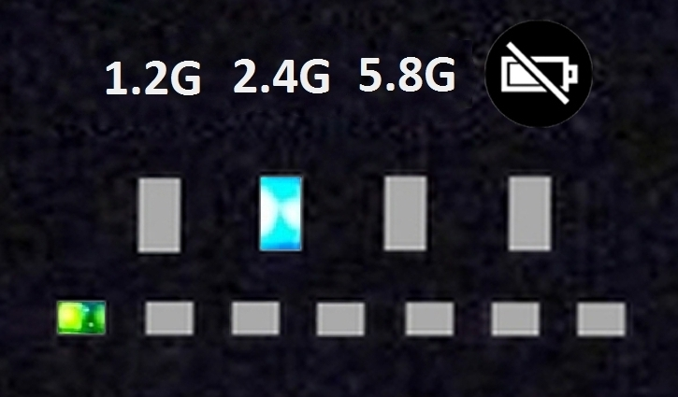
2. The Blue LED in upper row will light up at 2.4G and start to scan channel by channel, the Green LED will light up at first channel (CH1), each channel will take about 3 seconds to identify and verify. After verified WiFi activity, this device will vibrate and beep.
3. If this device only vibrate and beep twice, this means just other signal in same frequency, not signal of WiFi IP camera.

 LOCK CHANNEL
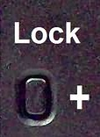
1. When identified WiFi activities, press (+) button in left side for 3 seconds to lock at current channel.
2. Turn the sensitivity counterclockwise to reduce the detection distance, then to approach the location of signal source.

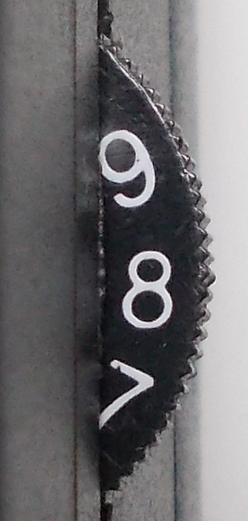
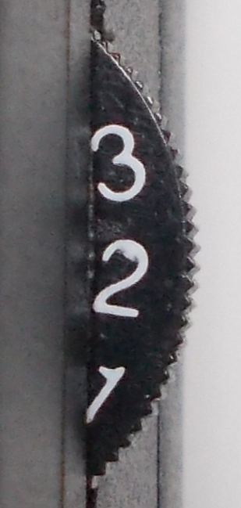
 SENSITIVITY ADJUSTMENT
1. There is a tuner in right side with number 9 ~ 1, this tuner is special for "WiFi IP camera scan mode" only. Default at 9 is the highest sensitivity; turn counterclockwise to lower the sensitivity, number 1 is the lowest sensitivity.
2. After verified the WiFi activity, this device will vibrate and beep. Turn the sensitivity tuner to "6" and wait for 5 seconds. If vibration and beep stop, forward one footstep and hold this device to scan half around to find the direction with WiFi activity.
3. If this device keeps vibration and beep, lower the sensitivity to "4", when vibration and beep stop, forward one footstep and hold this device to scan half around.
4. When verified the activity of WiFi again, according to above method, lower the sensitivity and forward one footstep, can approach to the location of signal source.

 NOTICE
1. This device detects the activities of WiFi signal, but does not read the WiFi data, so it will NOT display image of WiFi IP camera.
2. If detect other signal in same frequency as WiFi IP camera, this device will vibrate and beep twice and then go on to scan next channel.
3. Output strength of WiFi router is 100mW or higher, much stronger than WiFi IP camera (≦1mW). The detecting distance of WiFi IP camera is usually less than 0.5 meter for the lowest sensitivity at "1". If the detecting distance is still more than one meter, the signal source is probably WiFi router.

 SCAN CHANNEL
1. 2.4G WiFi: CH1 – CH13
2. 5G WiFi: CH 36 – CH 64, CH 149 – CH 165

