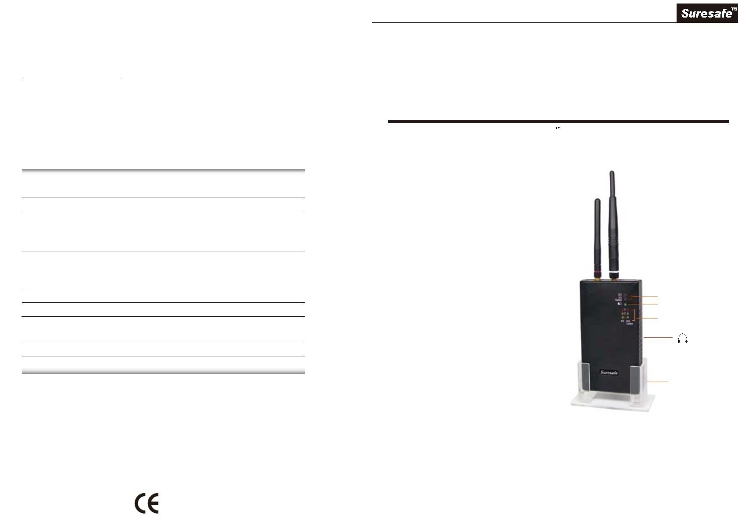

4. Always use the battery charger supplied by the manufacturer to avoid any
damage to the rechargeable battery. This device can be used during
charging.
NOTICE OF USE

2G / 3G / 4G / 5G (3300 ~ 3700MHz)
Cell Phone Detector
1. Never remove or change the antenna.
2. Unauthorized repair or dismantle of this device will void all the warranties.
3. Avoid water.
4. Do not store this device in an excessively hot place.
5. Avoid knocks or dropping this device.
User's Manual
Thank you for purchasing 2G/3G/4G Cell Phone Detector. Please
first read over this manual for proper use, save this manual and keep it handy.
SPECIFICATION
Power
1. Built-in rechargeable battery
2. Switching power adaptor
GENERAL
Battery life
About 4 hours after full charge
This device is made for detecting 2G
/ 3G / 4G / 5G (3300~3700MHz) cell phones radio waves in a place. This device also can detect WiFi, Bluetooth, wireless camera from 50 MHz - 6.0 GHz.
Detecting frequency band
1. 2G, 4G, 5G(3300~3700MHz) WiFi, Bluetooth
2. CDMA
3. 3G: WCDMA 2100 (UMTS)
Detecting distance
1. 3G (WCDMA) : up to 15 meters
2. GSM : up to 4 meters
3. CDMA , 4G, 5G(3300~3700MHz) : up to 4 meters
This device is special designed
insensitive with 2-way raido. So, it
will not be interfered with 2-way
Dimension
Weight
L 150 x W 80 x T 30 mm
About 310 g
Network indicator
radio easily. This feature makes
Power
this device well suited to use in
the places not allowed for
cellphone communication, yet the
security person communicate via
2-way radio.
Sensitive level
(Earphone)
1. Visible and audible alarm
Warning mode
2. Visible alarm, silent via earphone
Operation temperature
Humidity
0 - 40 centigrade
5% ~ 80%
It has network indication (LED) of
2G/Camera & 3G individually to
show the type of detected radio
waves. * 5G / 4G / WiFi / Bluetooth are indicated at 2G / 4G / Cam.
* Specifications may change without notice
WARNING
Acrylic seat
Use this device as an auxiliary, supplemental help or aid to prevent the risks caused by hidden camera, cellular phone or other wireless devices. This
device does not take the place of all the supervisions. Performance of this Radio frequency (RF) product will be affected by the circumstance of use.
The producer and marketing group accepts no liability for any loss or damage by malfunction or misuse.
When detected radio wave, the network indicator (LED) will blink in red. This
device has sensitivity tuner for 2G/4G/Camera & 3G individually for adjusting
the sensitivity and the detection distance.
COPYRIGHT
No part of this manual may be reproduced, transmitted, transcribed, or translated into any language in any form by any means, electrical or
mechanical, including photocopying, recording, or information and retrieval systems, without the express written permission of manufacturer.
Products mentioned in this manual are for identification purposes only. All brand names appearing in this manual may or may not be registered
trademarks or copyrights of their respective companies. The manufacturer reserves the right to change or modify the specifications of any one or
all of these products as deemed necessary at any time without prior notification. The manufacturer may further revise this manual from time to time
without prior notice.
This device has built-in rechargeable battery that can last for 4 hours
continuous use. When battery power runs down, the battery low warning
indication will light up in red to warn the user.
Copyright 2000-2023. All rights reserved.
PK1A
01.2023
Made in Taiwan.

HOW TO OPERATE
DETECTING INDICATION
1. Press down the On-Off switch
blinking
in red
and the power indicator in the
front side will light up in green.
2G/Camera/4G/5G/WiFi/Bluetooth detecting
indication:
On-Off switch Sensitivity turner
This picture shows this device detects 2G / Camera / 4G
5G / WiFi / Bluetooth radio wave, the network indicator
of 2G / 4G / Camera is blinking in red.
Battery charger jack
2. Then unbend the antennas, please always keep the antennas in vertical
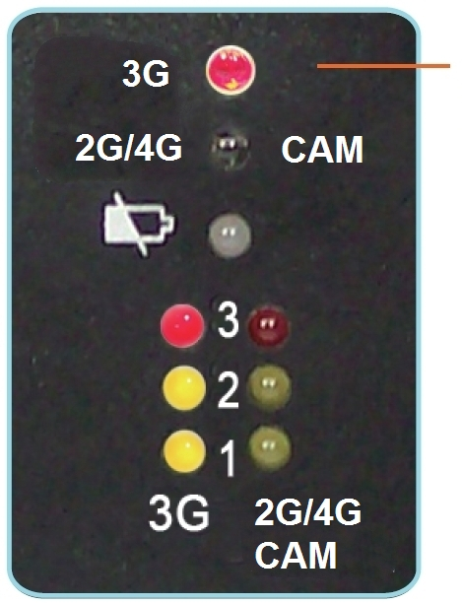And the 3 LEDs of 2G/4G/Cam sensitive level indicator
light up.
straight for better result.
3G detecting indication:
blinking
in red
3. Please be noted that the sensitivity adjustment of 2G/Camera/4G/5G/WiFi
/Bluetooth & 3G are different.
Setting the sensitivity level of 2G / Camera / 4G / 5G (3300~3700MHz) / WiFi / Bluetooth:
This picture shows this device detects 3G radio wave,
the network indicator of 3G is blinking in red.
And the 3 LEDs of 3G sensitive level indicator light up.
When detect the cell phone radio wave, you can reduce the sensitivity level
gradually to approach the signal source.
1. Turn the sensitivity tuner to +
(plus) side until the first yellow
LED light up.
Yellow LED
light up
BATTERY LOW WARNING
There is a battery low warning indication on the front side. When battery runs
down, the battery low warning LED will light up in red. Please connect the
battery charger to charge the battery.
2. Turn the sensitivity tuner to -
(minus) side to let the yellow
LED put out.
Yellow LED
put out
SILENT DETECTION
Note: Over sensitive or too low sensitive setting should affect the
detection ability.
There is an earphone jack in the right side of front view.
Connect the earphone to detect by earphone hearing.
Setting the sensitivity level of 3G:
ABOUT BATTERY
Turn the sensitivity tuner to + (plus) side at the maximum place. If one or
two LEDs (sensitive level indicator) light up, this is OK.
1. When the battery low warning LED light up in red. Connect the switching
power adaptor to continue the detecting and to recharge the battery at the
same time.
2. It will take about 7 hours to full charge the battery under POWER OFF
condition. If recharge under POWER ON condition, it will take about 16
hours to full charge the battery.
3. If you are not going to use this device for a long time, please set the On/Off
switch at Off and check the battery power once three months.
