- Hold this device to scan half around to detect the signal. Forward one footstep to the strongest signal direction. When the 8-LED signal strength indication all light up and the scan range (angle) over 120 degree, turn the sensitivity tuner to – (minus) side a little to lower down the sensitivity.
- The scan angle will become smaller. Hold this device to scan half around and forward one footstep to the strongest signal direction.
- Repeat above step 3 and 4, should be able to approach and then get the signal source.
- If lose the signal during locating the position of signal source, turn the sensitivity tuner to + (plus) side a little to raise the sensitivity until get the signal and continue the detection.

NOTICE OF USE
1. Unauthorized repair or disassembly of this device will void all the warranty.
2. Avoid water.
3. Do not store this device in an excessively hot place.
4. Avoid knock or drop of this device.
5. Never use the antenna of this device to touch a metal surface or the antenna of signal emission source. The quality warranty does not include the damage caused by static electricity or feed back.

Specifications * specification may change without prior notice
Detecting object | - Wideband jammer of Cellphone, WiFi, GPS, etc.  - Narrowband (L1) and wideband GPS jammer
Dimension | L 11.6 x W 7 x T 3.3 cm (not including antenna)
Weight | About 170g (not including battery)
Power | 1. AAA / UM-4rechargeable battery or dry battery x 4  2. 5V DC switching power adaptor
Warning mode | 1. LED | 2. Beep
Warning mode | 3. Vibration | 4. Identified indication
Bandwidth Resolution | FULL band detection
Frequency scan timing  for jamming signal | Always detecting
Handling of  jamming signal | Instant light up TRIGGER LED after verified the  jamming signal
Detecting distance | According to the output power of signal source

WARNING
Use this device as an auxiliary, supplemental help or aid to prevent the risks caused by GPS signal jammer or GSM signal jammer, etc. This device does not take the place of all the supervisions. Performance of this Radio frequency (RF) product will be affected by the circumstance of use. The producer and marketing group accepts no liability for any loss or damage by malfunction or misuse.

©Copyright 2023, All rights reserved. Made in Taiwan
09.2017
4
SH-055UJG
Professional Handheld GPS & Cellphone
Jamming Signal DETECTOR
Disclose interference with mobile & GPS communication

User's Manual

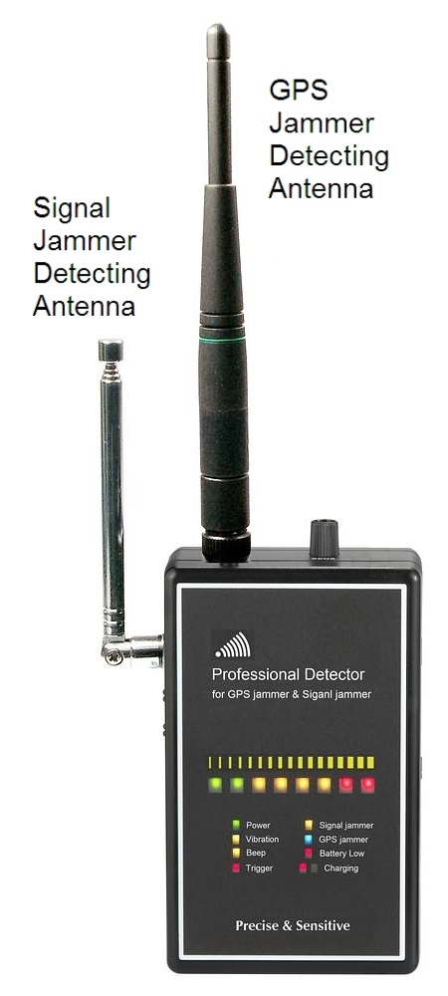
Thank you for purchasing the Suresafe Jamming Signal Detector. Please first read over this manual for proper use, save this manual and keep it handy.

GENERAL
This new handheld device can help Law enforce to scan cars on the road and to find if the criminal / car thief, hiding in car, uses GPS jammer to escape GPS tracking or, uses cellphone jammer to disable the mobile communication of GPS tracking system.

 INSTALL BATTERY
Battery compartment is located in the rear side. Remove the battery cover, install AAA / UM-4 battery x 4 according to the + – indication, then put on the battery cover. This device is available both dry battery and rechargeable battery.
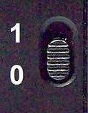
Note: Never connect the battery charger or external power bank when to use dry battery inside.
The power switch is located in the center of right side. Set at 1 to switch on, set at 0 to switch off.

 POWER-ON SELF-TEST
All the LEDs of this device will be lit up every time this device is switched on. Then the 8 Signal strength indication LEDs will be put out one-by-one.
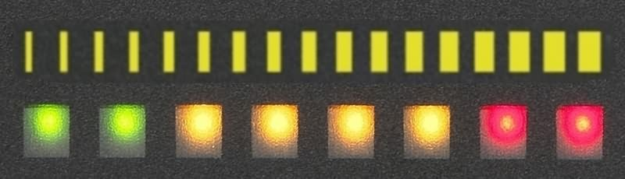
 8-LED SIGNAL STRENGTH INDICATION
The 8-LED bar will light up according to the signal strength from low to high, green → yellow → red, higher signal, more LED.

1
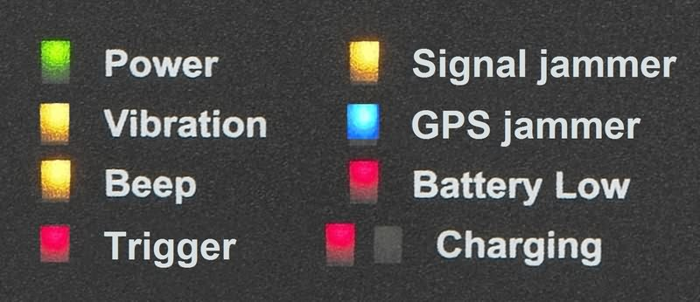
 SMART INDICATION OF ALL STATUS
1.
2.
3.
4.
6.
5.
8.
7.
We have tuned this device suitable for most environment, we strong suggest you do not adjust the sensitivity unless you will stay in the place with strong noise always.
No. | NAME | DESCRIPTION
1 | Power | Switch on
2 | Vibration | Vibration warning mode (manual shift)
3 | Beep | Beep sound warning mode (manual shift)
4 | Trigger | Jammer signal is verified
5 | Signal jammer | Wideband cellphone / WiFi / GPS jammer
6 | GPS jammer | Narrowband (L1) and wideband GPS jammer
7 | Battery low | Battery power running down
8 | Charging | Status of battery charging

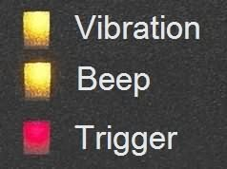

 3 WARNING MODES
Press once the lower button in left side can shift the warning mode between beep and vibration.
■ Trigger After jammer signal is verified, this LED will light up and will beep or vibrate to alert user at the same time.


 SELECT DETECTING OBJECT
Press once the upper button in left side can shift the detection mode between Signal jammer and GPS jammer.
- Signal jammer: Wideband jammer of cellphone, WiFi, GPS, etc.
- GPS jammer: Both narrowband (single channel) & wideband GPS jammer

 BATTERY & CHARGING STATUS
- Battery Low : When Battery Low LED lights up in red, it means the batteries run down. Please charge or replace the batteries.
- Charging: When starts charging, This indication lights up in red as quick charging, when charging to about 70%, it will change to slow charging, this indication will shift to green.

2
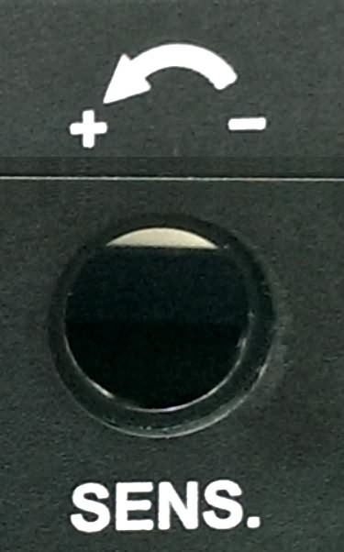
▲ SENSITIVITY ADJUSTMENT ▲
The default setting is at the position about 5 minute on clock.
Turn the Sensitivity Tuner to - (minus) side to decreases the sensitivity and the detecting distance will become shorter. Turn the Sensitivity Tuner to + (plus) side to increases the sensitivity and the detecting distance will become longer. ⬅ very small chance to change sensitivity.

 WITHOUT INTERFERE WITH CELLPHONE OR WIFI
This device will not be interfered with cellphone or WiFi, it will not cause any false alarm if someone uses cell phone nearby or install this device in the environment with WiFi, DECT phone or Bluetooth, etc.

 ENVIRONMENT NOISE FILTER
Most of the background noise or environment interference are below 500 MHz. To reduce the false alarm caused by background noise, this device has a unique filter to make it insensitive with the signal below 500 MHz.

HOW TO OPERATE
- Keep the antennas in vertical and turn on this device. This device will do power-on self-test.
- If more than one strength indication LEDs are blinking, please rest assured that the detected signal is not jamming signal.
- It this device beeps (vibrate) and the Trigger red LED light up, it means that this device detects jammer around.
- Refer to the chapter of “How to find (locate) the signal source” to find the position of signal source.
- To detect without other’s awareness, set the warning mode at Vibration or connect with earphone for silent detection.

 HOW TO FIND (LOCATE) THE SIGNAL SOURCE
1. Set the warning mode at Beep or connect earphone to find (locate) the signal source. Vibration is not suitable for finding the signal source.
2. Correct holding way of this device is the front side (with LED) facing to user and keep the antenna in upward.
3

