WARNING
Use this device as an auxiliary, supplemental help or aid to prevent the risks caused by cellular phone communications. This device does not take the place of all the supervisions. Performance of this Radio frequency (RF) product will be affected by the circumstance of use. The producer and marketing group accepts no liability for any loss or damage by malfunction or misuse.

COPYRIGHT
No part of this manual may be reproduced, transmitted, transcribed, or translated into any language in any form by any means, electrical or mechanical, including photocopying, recording, or information and retrieval systems, without the express written permission of manufacturer. Products mentioned in this manual are for identification purposes only. All brand names appearing in this manual may or may not be registered trademarks or copyrights of their respective companies. The manufacturer reserves the right to change or modify the specifications of any one or all of these products as deemed necessary at any time without prior notification. The manufacturer may further revise this manual from time to time without prior notice.


©Copyright 2023, All rights reserved.
Made in Taiwan 09.2022

8
SH-055UAAU 2G-3G-4G-5G (sub 6)
Mobile Phone Signal Detector
 Detect GSM / 3G / 4G / 5G Audio monitoring
 Detect 3G / 4G / 5G Video monitoring
 Clear display frequency & signal strength

User's Manual

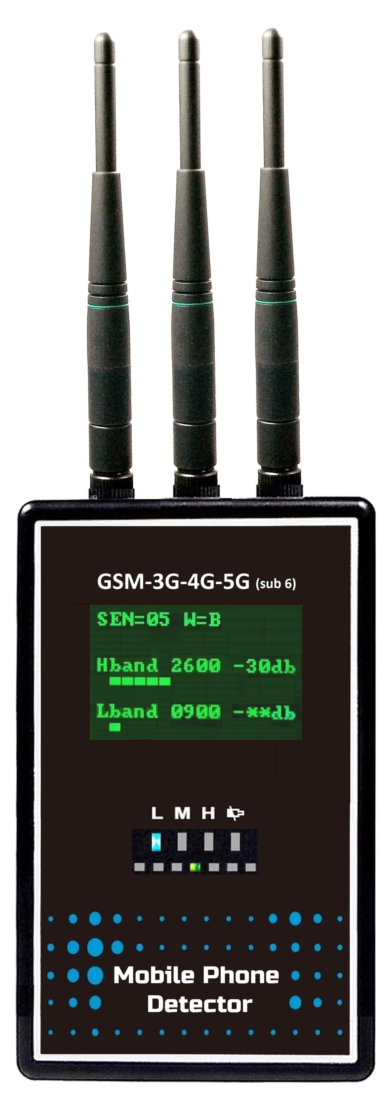
Thank you for purchasing this device. Please first read over this manual for proper use, save this manual and keep it handy.

GENERAL
This device has good detection capability for GSM / 3G / 4G / 5G (3300~3700MHz) mobile phone signals, including GSM / 3G / 4G / 5G Audio monitoring and 3G / 4G / 5G Video monitoring. It won't easily interfere with the signals of other frequency bands than mobile phones.

 INSTALL BATTERY
The battery compartment locates on the rear side. Remove the battery cover, install AAA / UM-4 battery x 4 according to the + – indication, then put on the battery cover. This device is available with both dry batteries and rechargeable batteries. Note: Never connect the battery charger or external power bank when using dry batteries.

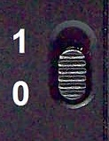
 SWITCH ON
The power switch is in the center of the right side, marked with 1 and 0. 1 i= turn on, 0 = turn off.

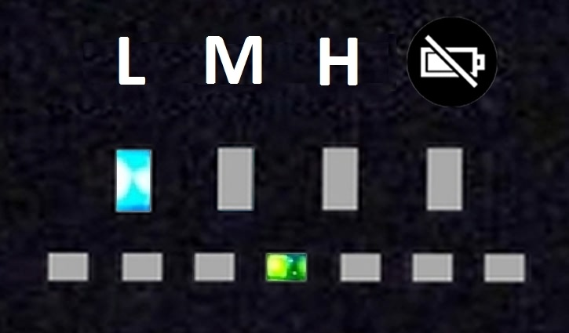
 INDICATION OF SENSITIVITY & SCANNING
After turn on, this device will scan the mobile phone signal automatically. There are two rows of LED displays under the LCD screen.
1
The upper row are Sensitivity benchmark and battery low indication. Three blue LEDs indicate L - M - H (Low - Medium - High) three sensitivity benchmark individually for the user to know the sensitivity setting. The LED on the very right side is a low battery warning (Bat Low), it will go red when battery power runs down.
The lower row is an indication of band scanning. During scanning, the green LED will shuttle to and fro.

 CLEAR LCD DISPLAY OF SETTINGS & SIGNAL INFO
The LCD screen displays settings of the Sensitivity level and Warning mode. When detecting mobile phone signals, the LCD screen will display the frequency band, the signal strength (dB value), and signal strength bars. Both ordinary users and professionals can smoothly check whether someone is using a mobile phone or remote monitoring devices using mobile phone technology.
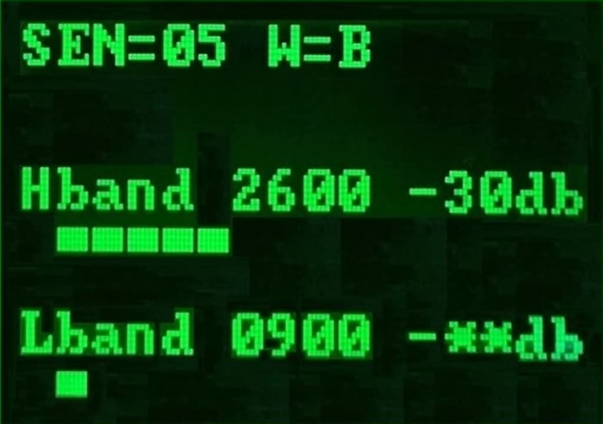 | No. | Display | Description
 | 1 |  | Sensitivity level
 | 2 |  | Warning mode
 | 3 | 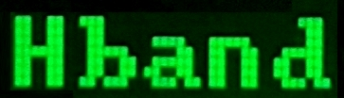 | High band
 | 4 | 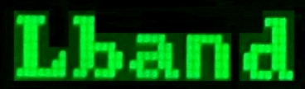 | Low band
 | 5 |  | Detected band
 | 6 | 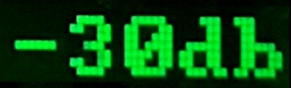 | Detected signal strength
 | 7 | 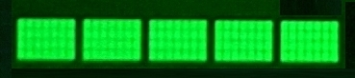 | Signal strength bar

 SENSITIVITY BENCHMARK & LEVEL
Sensitivity Benchmark | Level |  |  | 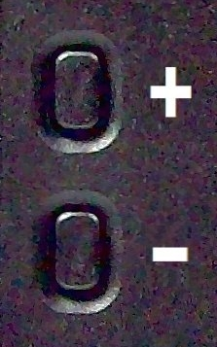
L (Low) | 00 - 09
M (Medium) | 10 - 19
H (High) | 20 - 29

2

NOTICE OF USE
- Unauthorized repair or disassembly of this device will void all the warranties.
- Avoid water.
- Do not store this device in an excessively hot place.
- Avoid knocks or dropping this device.
- Never use the antenna of this device to touch a metal surface or the antenna of the signal emission source. The quality warranty does not include the damage caused by static electricity or feedback.

 DETECTING FREQUENCY BAND
1. Australian : 700, 800, 900, 1800, 2100, 2300, 2600, 3500 MHz

 SPECIFICATION * Specification may change without prior notice.
Dimension |  | L 11.6 x W 7 x T 3.3 cm (not including antenna length)
Weight |  | About 215g
Power | Portable type | 1. AAA/UM-4 rechargeable battery x 4  2. 5V 1A USB charger  3. Support power bank
Detecting Frequency |  | Australian : 700, 800, 900, 1800, 2100, 2300, 2600,  3500 MHz
Warning  mode | Portable type | 1. Beep & Vibration (default) | 3. Beep
Warning  mode | Portable type | 2. Silent | 4. Vibration
Warning  mode | Fixed type | 1.0A Relay with NO-NC output
Battery life |  | About 6 hours (in standby) after fully charged
Battery charging time |  | About 6 hours to fully charge

7
3. Hold this device to scan half around and watch the signal strength. Forward one footstep to the direction with the highest signal strength. When the signal strength shows -00db in scan range (angle) over 120 degrees, press once the – (minus) button can lower one level of sensitivity.
4. Repeat the above step to approach the signal source gradually.
5. If the signal is missing during searching, press both+ (plus) and - (minus) buttons at the same time to unlock, and this device will start to scan again.

 SUPPORT POWER BANK FOR LONG TIME USE
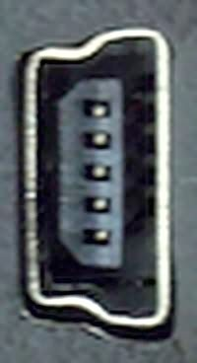
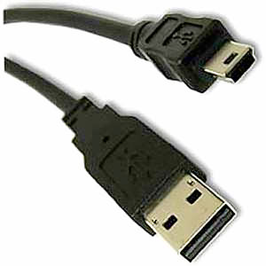
This device has a mini USB port on the right bottom side for connecting with the Power bank to continue the scan job when the battery power is exhausted.
○ NOTICE: Remove the DRY batteries inside before connecting with the power bank or battery charger.

 BATTERY & CHARGING STATUS
1. While the Battery Low LED lights up, it means the batteries run down. If used with rechargeable batteries, connect the battery charger or power bank to recharge the batteries and continue detection. If used with dry batteries, replace new batteries.
2. While starting to charge, the charging indication on the right bottom side of this device lights up in red as quick charging. While charging up to 70%, the charging indication will change to green as slow charging. It will take about 6 hours for fully charge.
3. While the batteries run down, and this device keeps turning on and does not connect with the battery charger or power bank, the batteries will be over-discharged, and the batteries will be damaged.
4. Batteries will be overcharged and damaged if keeping on charging this device. The producer and seller accept no liability for the damage caused by over-discharge or over-discharge.
5. If not use this device for a long time, remove the batteries to avoid the battery leakage damaging the circuit board.

6
1. This device has Low-Medium-High three benchmarks, which users can set the sensitivity benchmark according to the range wanting to be detected.
For example: to detect a big room or a high ceiling room, set the benchmark at High that could get a detection distance up to 20 meters radius. Please note that the detection distance is mainly based on the strength of the signal source.
To detect a small area, such as a prison cell, set the benchmark at Low that could get a detection distance up to 5 ~ 6 meters radius. Then it is not easy to cause misjudgment due to the detection of mobile phone signals from the next room.
2. Each of the three benchmarks has ten sensitivity levels for users fine-tuning the detection distance. When detecting mobile phone signals, lower the sensitivity gradually to get closer to the location of the signal source.
3. Default is Medium benchmark and sensitivity level 10, pressing ＋or － button on the left side to adjust the sensitivity level. Decreasing sensitivity lower to Level 9 will enter in Low benchmark, and increasing sensitivity up to Level 20 will enter in High benchmark. Reboot this device which will return to the default sensitivity.

 BUTTON FUNCTIONS
No. | Function | Activity
1 | Sensitivity Level + 1 | Press the + (plus) button once
2 | Sensitivity Level - 1 | Press the - (minus) button once
3 | Change warning mode  default is BV (beep + vibration)  → S (silent)  → B (beep)  → V (vibration)  → BV | Press and hold the - (minus) button
3 |  | 1. 1st time: Warning mode change from BV to S.  2. 2nd time: Warning mode change to B.  3. 3rd time: Warning mode change to V.  4. 4th time: Warning mode return to BV.
4 | Lock or Unlock Detected Frequency Band | Press both the + (plus) and the - (minus) button at the same time

3
 DETECTED FREQUENCY BAND
 | High band | 1800, 2100, 2300, 2600, 3500 MHz
 | Low band | 700, 800, 900 MHz

1. This display divide into two categories: Hband (high band) and Lband (low band) as listed above.
2. 5G Sub 6 frequency band: 3300 ~ 3700 MHz are displayed at 3500.
3. This device's scan will pass slightly faster for weaker signals (strength less than -40db). While this device detects a mobile phone signal over -40db continuously, it will hold the signal for a while to wait for the user to lock it. If the user does not want to trace this signal, lower the sensitivity level to skip this signal and go on scanning other mobile phone signals.
4. The -40db mentioned above is the measured value of this device, displayed with four strength bars.

 SIGNAL STRENGTH & STRENGTH BAR
No. | Signal  strength | Display  bar | No. | Signal  strength | Display  bar
1 | -＊＊db | 1 | 5 | -30db | 5
2 | -60db | 2 | 6 | -20db | 6
3 | -50db | 3 | 7 | -10db | 7
4 | -40db | 4 | 8 | -00db | 8

1. -＊＊db = No mobile phone signal detected
2. There are total 8 signal strength bars representing 7 levels of signal strength.

4
 FOUR WARNING MODES
 | BV | Beep + Vibration (Default) | B | Beep
 | V | Vibration | S | Silent
If set warning mode to Silent, plug in the earphone to detect by listening.

 HOW TO OPERATE

- Correct holding way of this device is the front side (with LED and speaker) facing the user and keeping the antenna vertical.
- At the earliest first startup, the screen will show the default sensitivity of Level 10 and the default warning mode BV (Beep + Vibration). Suppose the user changes the warning mode, so as Beep, then the next startup display of the warning mode will show B. Please refer to the chapter "BUTTON FUNCTIONS".
- After startup, this device will start to scan. When detected mobile phone signal, the screen will show the frequency band, signal strength, and strength bars.
- If none uses a mobile phone, the screen will show -＊＊db which means that no mobile phone signal was detected.
- Press once the + (plus) button will increase one level of sensitivity. Press once the - (minus) button will decrease one level of sensitivity. Higher sensitivity, longer detection distance.
- Please refer to the chapter "HOW TO APPROACH THE LOCATION OF SIGNAL SOURCE" to try finding the source of the detected mobile phone signal.

 HOW TO APPROACH THE LOCATION OF SIGNAL SOURCE
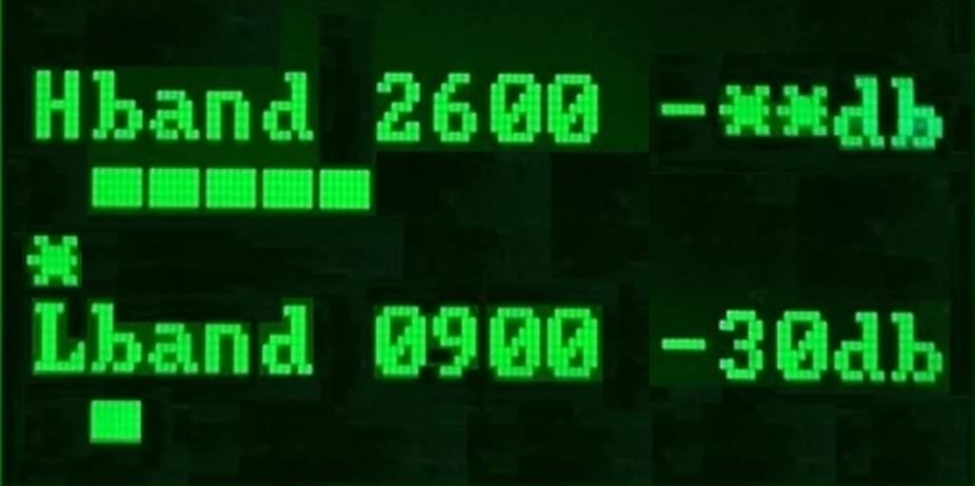
1. Set the warning mode to Beep or Silent to search signal source. The vibration mode is not suitable for searching signal sources. If set to Silent mode, remember to connect the earphone to search by listening.
2. press both+ (plus) and - (minus) buttons at the same time to lock the detected frequency band. An asterisk will appear above the locked band.
5

